CLOUD SOLUTIONS – 3ª Sprint

B2BShift

Grupo(RMs): 555113,555799,557420,557839,558881

Evidências – Serviços criados no GCP

* gcp-b2bshift-iac\bigquery.tf

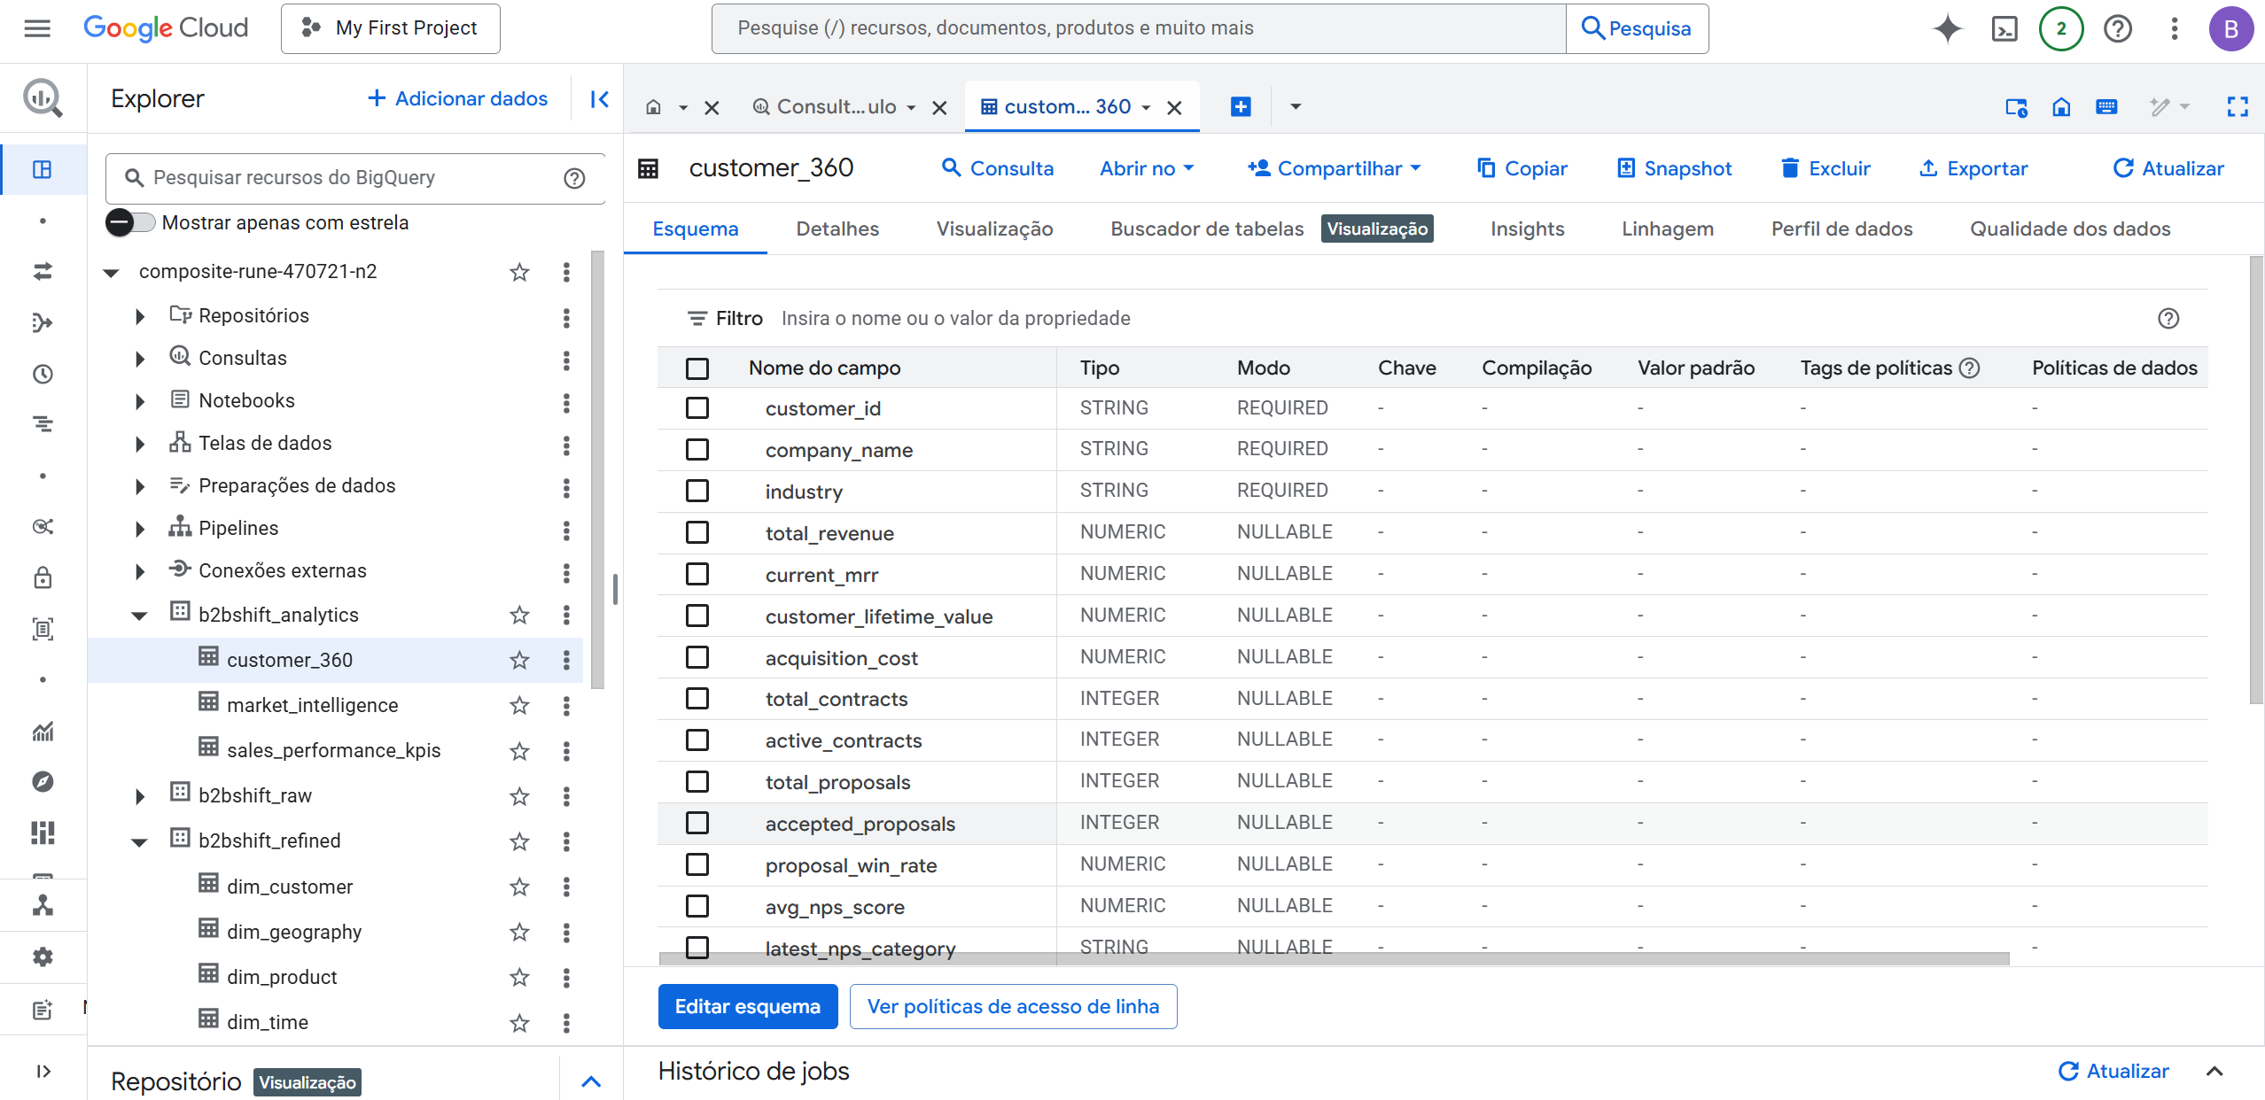

* gcp-b2bshift-iac\composer.tf

* gcp-b2bshift-iac\dataflow.tf

* gcp-b2bshift-iac\dataplex.tf

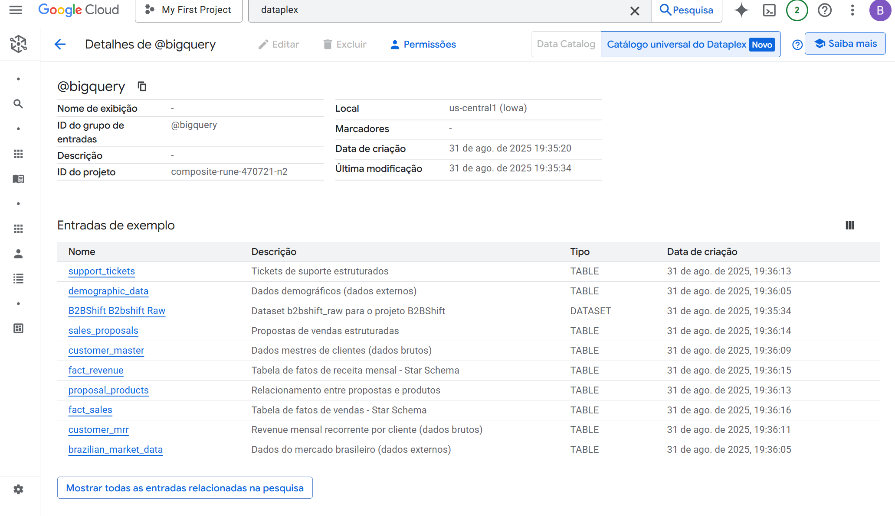

* gcp-b2bshift-iac\dataproc.tf

* gcp-b2bshift-iac\storage.tf

* gcp-b2bshift-iac\vertex_ai.tf

